Jeffery Bills

D212 Task 2 Market Basket Analysis

### **SCENARIO**

One of the most critical factors in customer relationship management that directly affects a company’s long-term profitability is understanding its customers. When a company can better understand its customer characteristics, it is better able to target products and marketing campaigns for customers, resulting in better profits for the company in the long term.

Introduction

Below I load in the dataset and examine it before analysis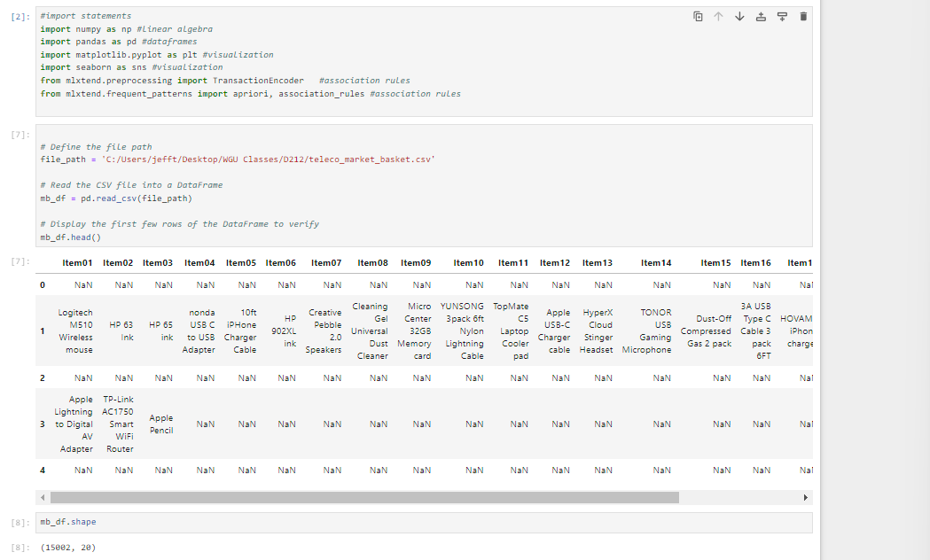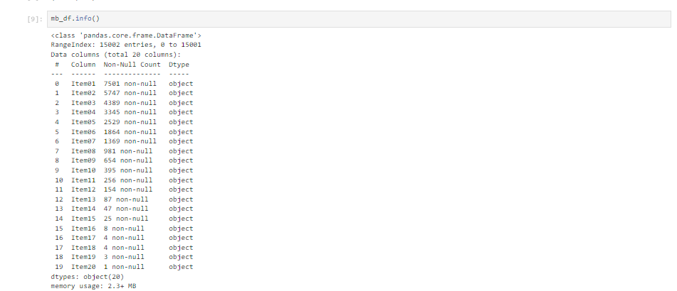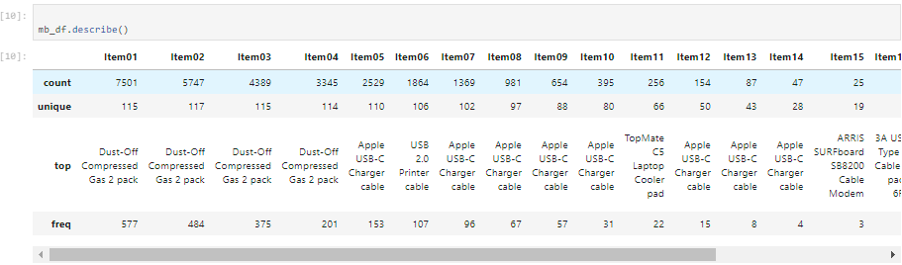

### **Part I: Research Question**

#### **A. Describe the purpose of this data mining report by doing the following:**

1. Propose one question relevant to a real-world organizational situation that you will answer using market basket analysis.

I am investigating is it possible to identify frequent itemsets—combinations of goods and services that are regularly bought together—by looking through transaction data. By examining transaction data, frequent itemsets can be identified—combinations of products/services frequently purchased together. These insights enable businesses to recommend bundled packages that align with customer preferences and purchasing behaviors. Additionally, understanding these common bundles facilitates targeted marketing strategies and enhances customer satisfaction by offering cohesive and appealing product/service combinations.

1. Define one goal of the data analysis. Ensure that your goal is reasonable within the scope of the scenario and is represented in the available data.

Finding relationships between the items in the dataset is the aim of this research, which will also identify the most common product and service bundles that consumers buy. I can find patterns where the purchase of one item is connected with the purchase of another by using methods such as association rule mining. By using this method, we may find item sets that customers commonly co-purchase, which gives us important information about their preferences and purchasing patterns. These insights play a critical role in developing strategies for bundled package recommendations that align with client interests and improve overall customer happiness and service performance.

### **Part II: Market Basket Justification**

#### **B. Explain the reasons for using market basket analysis by doing the following:**

By applying lift and apriori principles, market basket analysis offers important insights into the typical associations between products or events. For example, when a consumer purchases a muffin, they probably will also buy a glass of milk. Businesses can use this analytical method to evaluate the possibility of these correlations and predict what customers would want (antecedent) in response to a certain purchase (precedent).The expected outcome involves establishing rules that link initial purchase antecedents with subsequent purchases. This includes quantifying the support of individual items and item groups (their purchase frequency relative to the entire dataset). Confidence ratios are then calculated for items or combinations of items, indicating the probability of one item being purchased given another. Additionally, a lift score is computed, which measures the strength of the association between items based on transaction data. A low lift suggests that items are purchased independently (e.g., coloring books and car oil), while a high lift indicates items frequently purchased together (e.g., Italian food and breadsticks).

1. Provide one example of transactions in the dataset.

Purchasing a 2-pack of compressed air duster as the antecedent (prior purchase) and an Apple Pencil as the consequent (follow-up purchase) is one example of an observed transaction in the dataset. This correlation points to a possible trend in which buyers of compressed air dusters are also inclined to buy Apple Pencils. Business tactics, such product bundling or focused marketing, can be informed by transaction data insights to leverage observed purchasing patterns.

1. Summarize one assumption of market basket analysis.

Market Basket Analysis relies on the assumption that there must be a significant and measurable frequency of item occurrences to derive meaningful association scores. For example, your restaurant may consistently sell breadsticks with spaghetti, but if these items are not popular menu choices, Market Basket Analysis may fail to detect or highlight this association. The effectiveness of Market Basket Analysis heavily depends on the frequency and popularity of item combinations within the dataset, ensuring that meaningful conclusions can be drawn based on observed patterns of item co-occurrence.

### **Part III: Data Preparation and Analysis**

#### **C. Prepare and perform market basket analysis by doing the following:**

1. Transform the dataset to make it suitable for market basket analysis. Include a copy of the cleaned dataset.

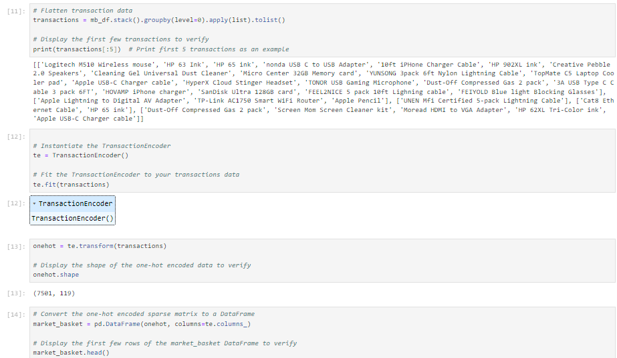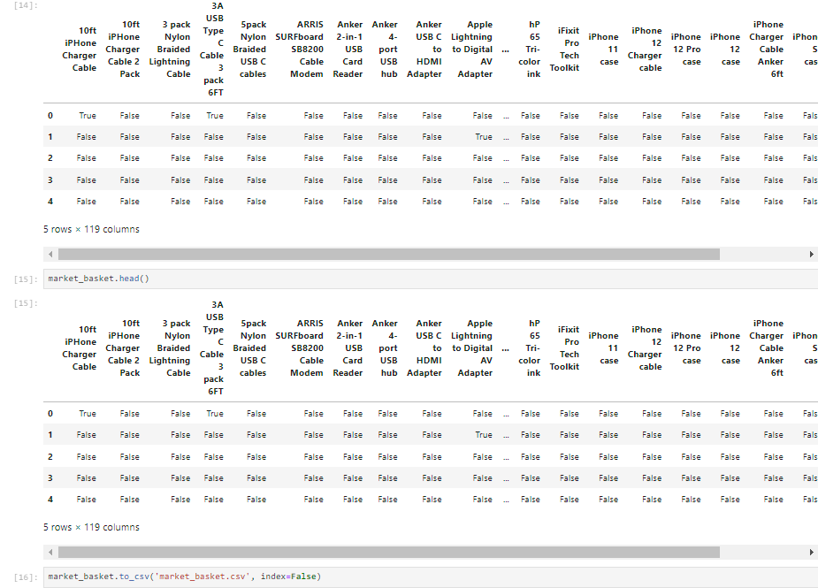

1. Execute the code used to generate association rules with the Apriori algorithm. Provide screenshots that demonstrate the error-free functionality of the code.

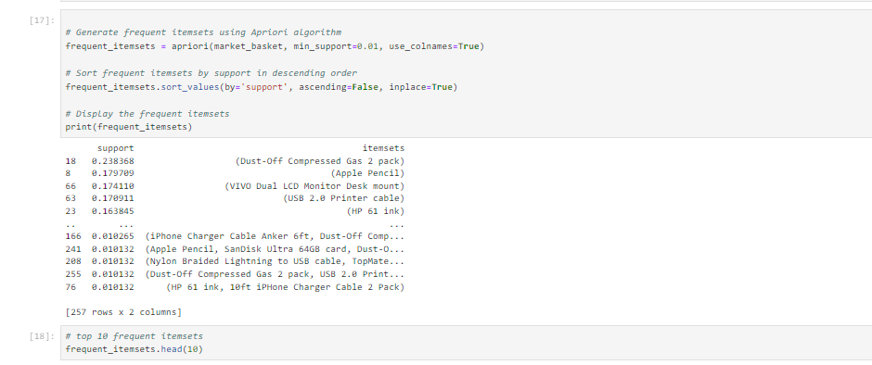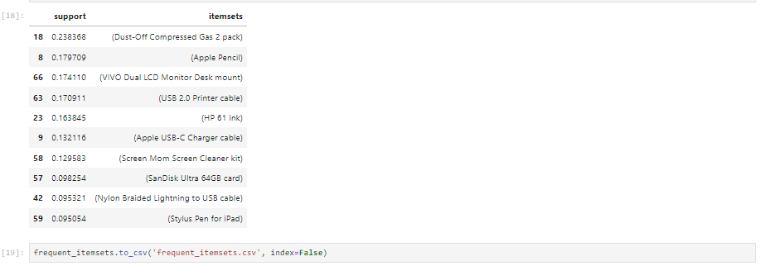3. Provide values for the support, lift, and confidence of the association rules table.

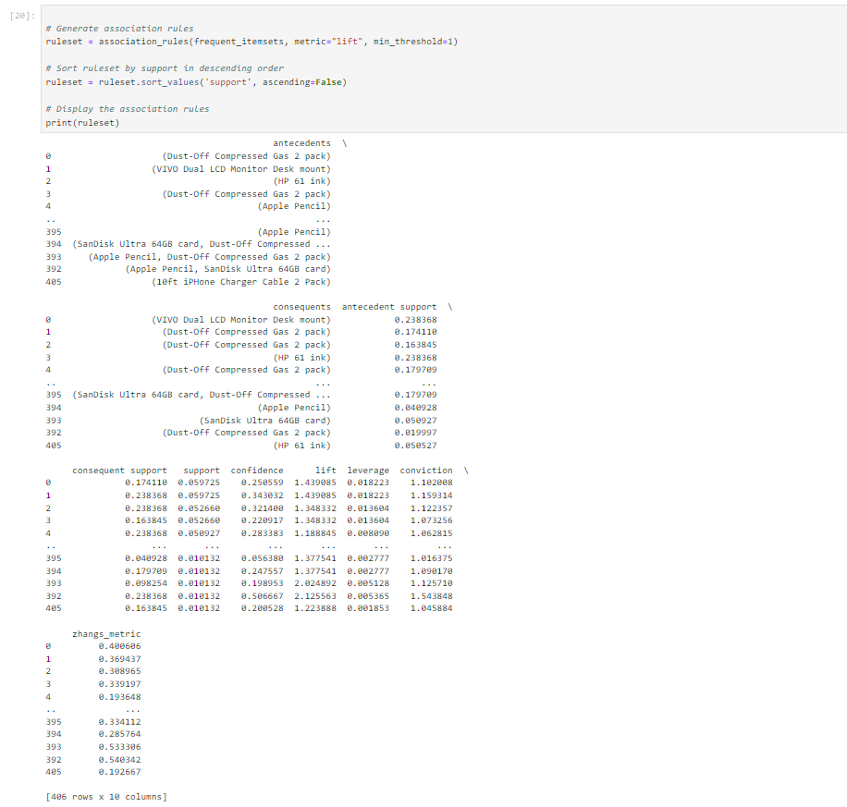

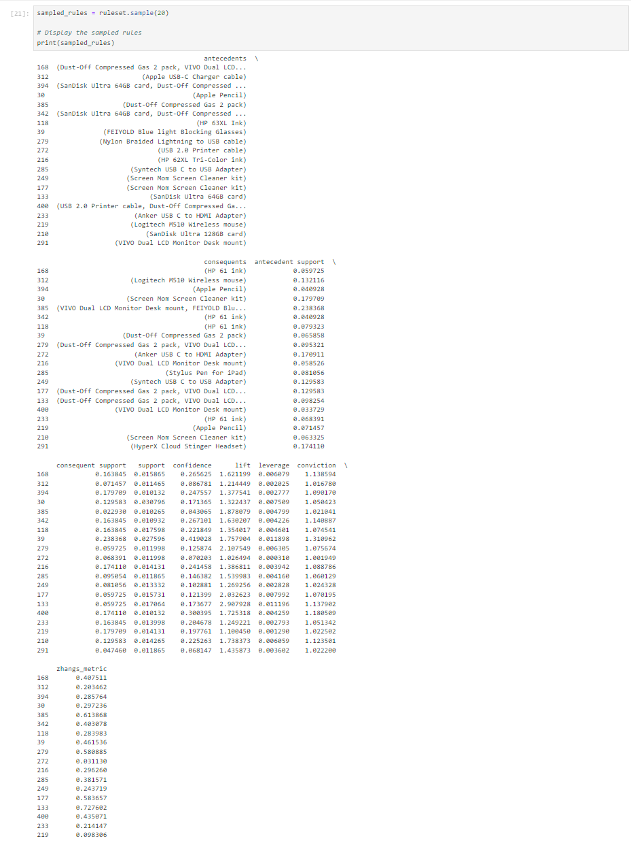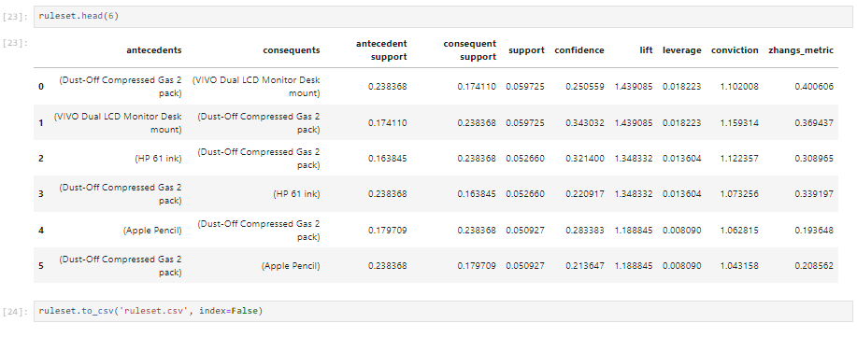

### **Part IV: Data Summary and Implications**

#### **D. Summarize your data analysis by doing the following:**

1. Summarize the significance of support, lift, and confidence from the results of the analysis.

The percentage of dataset transactions that contain both the antecedent and consequent items is represented by a rule's support. The probability of buying the consequent given the antecedent is expressed as confidence, which is calculated by dividing the proportion of transactions with both items by those with just the antecedent. Lift, on the other hand, provides a measure of the strength of the relationship between the antecedent and consequent by comparing the confidence of a rule to the expected confidence if they were independent. Independent relationships are indicated by a lift of 1, and positive or negative associations are indicated by values larger or less than 1.

The top three rules in this dataset indicate a higher possibility of being purchased in conjunction: Dust-Off Compressed Gas 2 pack & VIVO Dual LCD Monitor Desk mount; Dust-Off Compressed Gas 2 pack & HP 61 ink; and Dust-Off Compressed Gas 2 pack & Apple Pencil. This implies that Dust-Off Compressed Gas 2 pack is frequently offered in combination with other products. The support for each of these rules ranges from 0.05 to 0.059, meaning that roughly 5% of all transactions are covered by them. The confidence, which ranges from 0.21 to 0.34, differs among these regulations, though. When Dust-Off Compressed Gas 2 pack is the antecedent item, higher confidence scores are seen, suggesting a higher chance that the consequent item will be purchased when the antecedent is present.

2.Discuss the practical significance of the findings from the analysis.

According to this summary of the main guidelines, customers often intend to purchase specific products such as monitors but end up buying Dust-Off Compressed Gas instead. The strategic placement of Dust-Off Air next to the checkout aisle may influence these impulsive purchases, which may not necessarily correlate with the initial item of interest. To improve accuracy, it is advisable to exclude "door busters" or impulsive purchases from the dataset. These items can distort association patterns in market basket analysis, ensuring that the conclusions drawn from the study accurately reflect meaningful relationships and consumer purchasing patterns.

1. Recommend a course of action for the real-world organizational situation from part A1 based on your results from part D1.

They may need to move goods or adjust their promotion to suit the needs and preferences of their customer.

Sources:

365 Data Science. (n.d.). Market basket analysis. Retrieved July 14, 2024, from<https://365datascience.com/tutorials/python-tutorials/market-basket-analysis/>